LAPORAN PRAKTIKUM
PEMROGRAMAN MOBILE
MODUL 5



Connect to the Internet

Oleh:
Muhammad Guntur Ricky Adhitya NIM. 2410817310003

PROGRAM STUDI TEKNOLOGI INFORMASI
FAKULTAS TEKNIK
UNIVERSITAS LAMBUNG MANGKURAT
JUNI 2026

LEMBAR PENGESAHAN
LAPORAN PRAKTIKUM PEMROGRAMAN MOBILE
MODUL 5

Laporan Praktikum Pemrograman Mobile Modul 5: Connect to the Internet ini disusun sebagai syarat lulus mata kuliah Praktikum Pemrograman Mobile. Laporan Praktikum ini dikerjakan oleh:

Nama Praktikan | : Muhammad Guntur Ricky Adhitya
NIM | : 2410817310003

Menyetujui,
Asisten Praktikum

Muhammad Erza Raihan
NIM. 2310817210027
Menyetujui,
Dosen Penanggung Jawab Praktikum

Irham Maulani Abdul Gani, S.Kom., M.Kom.
NIP. 199710312025061009

DAFTAR ISI
LEMBAR PENGESAHAN 2
DAFTAR ISI 3
DAFTAR GAMBAR 4
DAFTAR TABEL 5
SOAL 1 6
A. Source Code 7
B. Output Program 59
C. Pembahasan 68
LINK GITHUB 73

DAFTAR GAMBAR
Gambar 1. Output Screenshot Modul 5 (Indonesia) 59
Gambar 2. Output Screenshot Modul 5 (Settings) 60
Gambar 3. Output Screenshot Modul 5 (Spanyol) 61
Gambar 4. Output Screenshot Modul 5 (Detail Page) 62
Gambar 5. Output Screenshot Modul 5 (Implicit Intent) 63
Gambar 6. Output Screenshot Modul 5 (Landscape Orientation) 64
Gambar 7. Output Screenshot Modul 5 (Prancis) 65
Gambar 8. Output Screenshot Modul 5 (Inggris) 66
Gambar 9. Output Screenshot Modul 5 (Jerman) 67

DAFTAR TABEL
Tabel 1. Source Code MainActivity.kt Modul 5 7
Tabel 2. Source Code Modul5Compose.kt Modul 5 8
Tabel 3. Source Code MovieResponse.kt Modul 5 9
Tabel 4. Source Code Resource.kt Modul 5 10
Tabel 5. Source Code SettingsRepository.kt Modul 5 10
Tabel 6. Source Code TmdbListResponse.kt Modul 5 12
Tabel 7. Source Code MovieEntity.kt Modul 5 13
Tabel 8. Source Code MovieDao.kt Modul 5 13
Tabel 9. Source Code AppDatabase.kt Modul 5 14
Tabel 10. Source Code RoutingNames.kt Modul 5 15
Tabel 11. Source Code AppNavigation.kt Modul 5 16
Tabel 12. Source Code HttpClientFactory.kt Modul 5 18
Tabel 13. Source Code TmdbHttpClientFactory.kt Modul 5 19
Tabel 14. Source Code BaseRepository.kt Modul 5 20
Tabel 15. Source Code MovieRepository.kt Modul 5 21
Tabel 16. Source Code NetworkBoundResource.kt Modul 5 24
Tabel 17. Source Code DetailScreen.kt Modul 5 26
Tabel 18. Source Code DetailState.kt Modul 5 32
Tabel 19. Source Code DetailViewModel.kt Modul 5 32
Tabel 20. Source Code DetailViewModelFactory.kt Modul 5 33
Tabel 21. Source Code HomeState.kt Modul 5 34
Tabel 22. Source Code HomeViewModel.kt Modul 5 35
Tabel 23. Source Code HomeScreen.kt Modul 5 38
Tabel 24. Source Code HomeViewModelFactory.kt Modul 5 48
Tabel 25. Source Code LanguageScreen.kt Modul 5 49
Tabel 26. Source Code LanguageState.kt Modul 5 53
Tabel 27. Source Code LanguageModel.kt Modul 5 54
Tabel 28. Source Code LanguageViewModel.kt Modul 5 54
Tabel 29. Source Code LanguageViewModelFactory.kt Modul 5 56
Tabel 30. Source Code MovieHelper.kt Modul 5 57

SOAL 1
Soal Praktikum:
- Lanjutkan aplikasi Android yang sudah dibuat pada Modul 4 dengan menambahkan modifikasi sesuai ketentuan berikut:
- Gunakan networking library seperti Retrofit atau Ktor agar aplikasi dapat mengambil data dari remote API. Dalam penggunaan networking library, sertakan generic response untuk status dan error handling pada API dan Flow untuk data stream.
- Gunakan KotlinX Serialization sebagai library JSON.
- Gunakan library seperti Coil atau Glide untuk image loading.
- API yang digunakan pada modul ini adalah The Movie Database (TMDB) API yang menampilkan data film. Berikut link dokumentasi API: https://developer.themoviedb.org/docs/getting-started
- Implementasikan konsep data persistence (aplikasi menyimpan data walau pengguna keluar dari aplikasi) dengan SharedPreferences untuk menyimpan data ringan (seperti pengaturan aplikasi) dan Room untuk data relasional.
- Gunakan caching strategy pada Room. Dibebaskan untuk memilih caching strategy yang sesuai, dan sertakan penjelasan kenapa menggunakan caching strategy tersebut.
- Untuk Modul 5, bebas memilih UI yang ingin digunakan, antara berbasis XML atau Jetpack Compose.
Aplikasi harus mempertahankan fitur-fitur yang dibuat pada modul sebelumnya.

Source Code
1. Main
Tabel 1. Source Code MainActivity.kt Modul 5
1 | package com.mobil.modul5compose
2
3 | import android.os.Bundle
4 | import androidx.activity.compose.setContent
5 | import androidx.activity.enableEdgeToEdge
6 | import androidx.appcompat.app.AppCompatActivity
7 | import androidx.navigation.compose.rememberNavController
8 | import com.mobil.modul5compose.navigation.AppNavigation
9 | import com.mobil.modul5compose.ui.theme.Modul3ComposeTheme
10
11 | class MainActivity : AppCompatActivity() {
12
13 | override fun onCreate(savedInstanceState: Bundle?) {
14 | super.onCreate(savedInstanceState)
15 | enableEdgeToEdge()
16
17 | val app = application as Modul5Application
18
19 | setContent {
20 | Modul3ComposeTheme {
21 | val navController = rememberNavController()
22 | AppNavigation(
23 | navController = navController,
24 | settingsRepository = app.settingsRepository,
25 | movieRepository = app.movieRepository
26 | )
27 | }
28 | }
29 | }
30 | }

Tabel 2. Source Code Modul5Compose.kt Modul 5
1 | package com.mobil.modul5compose
2
3 | import android.app.Application
4 | import androidx.room.Room
5 | import com.mobil.modul5compose.data.SettingsRepository
6 | import com.mobil.modul5compose.data.local.AppDatabase
7 | import com.mobil.modul5compose.network.MovieRepository
8 | import com.mobil.modul5compose.network.TmdbHttpClientFactory
9 | import timber.log.Timber
10
11 | class Modul5Application : Application() {
12 | lateinit var settingsRepository: SettingsRepository
13 | lateinit var movieRepository: MovieRepository
14
15 | override fun onCreate() {
16 | super.onCreate()
17
18 | if (BuildConfig.DEBUG) {
19 | Timber.plant(Timber.DebugTree())
20 | }
21
22 | settingsRepository = SettingsRepository(this)
23
24 | val database = Room.databaseBuilder(this, AppDatabase::class.java, "movie_db")
25 | .fallbackToDestructiveMigration(false)
26 | .build()
27
28 | val httpClient = TmdbHttpClientFactory(BuildConfig.READ_ACCESS_TOKEN).create()
29 | movieRepository = MovieRepository(httpClient, database.movieDao(), settingsRepository)
30 | }
31 | }

2. Data
Tabel 3. Source Code MovieResponse.kt Modul 5
1 | package com.mobil.modul5compose.data
2
3 | import kotlinx.serialization.SerialName
4 | import kotlinx.serialization.Serializable
5
6 | @Serializable
7 | data class MovieResponse(
8 | val id: Int,
9 | val title: String? = null,
10 | val overview: String? = null,
11 | @SerialName("poster_path") val posterPath: String? = null,
12 | @SerialName("release_date") val releaseDate: String? = null,
13 | @SerialName("vote_average") val voteAverage: Double? = null,
14 | @SerialName("original_title") val originalTitle: String? = null
15 | )

Tabel 4. Source Code Resource.kt Modul 5
1 | package com.mobil.modul5compose.data
2
3 | sealed interface Resource<out T> {
4 | data class Success<T>(val data: T) : Resource<T>
5 | data class Error<T>(val exception: Throwable, val data: T? = null) : Resource<T>
6 | data class Loading<T>(val data: T? = null) : Resource<T>
7 | }

Tabel 5. Source Code SettingsRepository.kt Modul 5
1 | package com.mobil.modul5compose.data
2
3 | import android.content.Context
4 | import android.content.SharedPreferences
5 | import com.mobil.modul5compose.ui.screens.language.LanguageModel
6 | import timber.log.Timber
7 | import kotlinx.coroutines.flow.MutableStateFlow
8 | import kotlinx.coroutines.flow.StateFlow
9 | import kotlinx.coroutines.flow.asStateFlow
10
11 | class SettingsRepository(context: Context) {
12 | private val prefs: SharedPreferences = context.getSharedPreferences(PREFS_NAME, Context.MODE_PRIVATE)
13
14 | private val _languageTag = MutableStateFlow(getLanguageTag())
15 | val languageTag: StateFlow<String> = _languageTag.asStateFlow()
16
17 | fun getLanguageTag(): String {
18 | return prefs.getString(KEY_LANGUAGE, "en-US") ?: "en-US"
19 | }
20
21 | fun saveLanguageTag(tag: String) {
22 | Timber.d("Saving language tag to SharedPreferences: %s", tag)
23 | prefs.edit().putString(KEY_LANGUAGE, tag).apply()
24 | _languageTag.value = tag
25 | }
26
27 | fun getAvailableLanguages(): List<LanguageModel> {
28 | return defaultLanguages()
29 | }
30
31 | private fun defaultLanguages() = listOf(
32 | LanguageModel("English", "en-US"),
33 | LanguageModel("Bahasa Indonesia", "id-ID"),
34 | LanguageModel("Español", "es-ES"),
35 | LanguageModel("Français", "fr-FR"),
36 | LanguageModel("Deutsch", "de-DE")
37 | )
38
39 | companion object {
40 | private const val PREFS_NAME = "app_settings"
41 | private const val KEY_LANGUAGE = "language_tag"
42 | }
43 | }

Tabel 6. Source Code TmdbListResponse.kt Modul 5
1 | package com.mobil.modul5compose.data
2
3 | import kotlinx.serialization.Serializable
4
5 | @Serializable
6 | data class TmdbListResponse(
7 | val results: List<MovieResponse>
8 | )

3. Data.Local
Tabel 7. Source Code MovieEntity.kt Modul 5
1 | package com.mobil.modul5compose.data.local
2
3 | import androidx.room.Entity
4 | import androidx.room.PrimaryKey
5
6 | @Entity(tableName = "movies")
7 | data class MovieEntity(
8 | @PrimaryKey
9 | val id: Int,
10 | val title: String,
11 | val overview: String,
12 | val posterPath: String,
13 | val releaseDate: String,
14 | val voteAverage: Double,
15 | val languageTag: String,
16 | val cachedAt: Long = System.currentTimeMillis()
17 | )

Tabel 8. Source Code MovieDao.kt Modul 5
1 | package com.mobil.modul5compose.data.local
2
3 | import androidx.room.Dao
4 | import androidx.room.Insert
5 | import androidx.room.OnConflictStrategy
6 | import androidx.room.Query
7 | import kotlinx.coroutines.flow.Flow
8
9 | @Dao
10 | interface MovieDao {
11 | @Query("SELECT * FROM movies WHERE languageTag = :languageTag ORDER BY cachedAt DESC")
12 | fun getAllMovies(languageTag: String): Flow<List<MovieEntity>>
13
14 | @Query("SELECT * FROM movies WHERE id = :movieId AND languageTag = :languageTag")
15 | fun getMovieById(movieId: Int, languageTag: String): Flow<MovieEntity>
16
17 | @Insert(onConflict = OnConflictStrategy.REPLACE)
18 | suspend fun insertMovie(movie: MovieEntity)
19
20 | @Insert(onConflict = OnConflictStrategy.REPLACE)
21 | suspend fun insertMovie(movie: List<MovieEntity>)
22
23 | @Query("DELETE FROM movies")
24 | suspend fun clearAllMovies()
25 | }

4. Navigation
Tabel 9. Source Code AppDatabase.kt Modul 5
1 | package com.mobil.modul5compose.data.local
2
3 | import androidx.room.Database
4 | import androidx.room.RoomDatabase
5
6 | @Database(
7 | entities = [MovieEntity::class],
8 | version = 1,
9 | exportSchema = false
10 | )
11 | abstract class AppDatabase: RoomDatabase() {
12 | abstract fun movieDao(): MovieDao
13 | }

Tabel 10. Source Code RoutingNames.kt Modul 5
1 | package com.mobil.modul5compose.navigation
2
3 | import kotlinx.serialization.Serializable
4
5 | @Serializable
6 | sealed class RoutingNames {
7 | @Serializable
8 | object HomeScreen : RoutingNames()
9
10 | @Serializable
11 | data class DetailScreen(
12 | val movieId: Int
13 | ) : RoutingNames()
14
15 | @Serializable
16 | object LanguageScreen: RoutingNames()
17 | }

Tabel 11. Source Code AppNavigation.kt Modul 5
1 | package com.mobil.modul5compose.navigation
2
3 | import androidx.compose.runtime.Composable
4 | import androidx.compose.runtime.remember
5 | import androidx.lifecycle.viewmodel.compose.viewModel
6 | import androidx.navigation.NavHostController
7 | import androidx.navigation.compose.NavHost
8 | import androidx.navigation.compose.composable
9 | import androidx.navigation.toRoute
10 | import com.mobil.modul5compose.data.SettingsRepository
11 | import com.mobil.modul5compose.data.local.MovieDao
12 | import com.mobil.modul5compose.network.MovieRepository
13 | import com.mobil.modul5compose.ui.screens.detail.DetailScreen
14 | import com.mobil.modul5compose.ui.screens.detail.DetailViewModel
15 | import com.mobil.modul5compose.ui.screens.detail.DetailViewModelFactory
16 | import com.mobil.modul5compose.ui.screens.home.HomeScreen
17 | import com.mobil.modul5compose.ui.screens.home.HomeViewModel
18 | import com.mobil.modul5compose.ui.screens.home.HomeViewModelFactory
19 | import com.mobil.modul5compose.ui.screens.language.LanguageScreen
20 | import com.mobil.modul5compose.ui.screens.language.LanguageViewModel
21 | import com.mobil.modul5compose.ui.screens.language.LanguageViewModelFactory
22
23 | @Composable
24 | fun AppNavigation(
25 | navController: NavHostController,
26 | settingsRepository: SettingsRepository,
27 | movieRepository: MovieRepository
28 | ) {
29 | NavHost(navController = navController, startDestination = RoutingNames.HomeScreen) {
30 | composable<RoutingNames.HomeScreen> {
31 | val factory = remember { HomeViewModelFactory(movieRepository) }
32 | val viewModel: HomeViewModel = viewModel(factory = factory)
33 | HomeScreen(navController, viewModel)
34 | }
35 | composable<RoutingNames.DetailScreen> { navBackStack ->
36 | val detailArgs = navBackStack.toRoute<RoutingNames.DetailScreen>()
37 | val factory = remember { DetailViewModelFactory(movieRepository, detailArgs.movieId) }
38 | val viewModel: DetailViewModel = viewModel(factory = factory)
39 | DetailScreen(viewModel) { navController.popBackStack() }
40 | }
41 | composable<RoutingNames.LanguageScreen> {
42 | val factory = remember { LanguageViewModelFactory(settingsRepository) }
43 | val viewModel: LanguageViewModel = viewModel(factory = factory)
44 | LanguageScreen(navController, viewModel)
45 | }
46 | }
47 | }

5. Network

Tabel 12. Source Code HttpClientFactory.kt Modul 5
1 | package com.mobil.modul5compose.network
2
3 | import io.ktor.client.HttpClient
4
5 | interface HttpClientFactory {
6 | fun create(): HttpClient
7 | }

Tabel 13. Source Code TmdbHttpClientFactory.kt Modul 5
1 | package com.mobil.modul5compose.network
2
3 | import io.ktor.client.HttpClient
4 | import io.ktor.client.engine.cio.CIO
5 | import io.ktor.client.plugins.contentnegotiation.ContentNegotiation
6 | import io.ktor.client.plugins.defaultRequest
7 | import io.ktor.client.request.header
8 | import io.ktor.http.ContentType
9 | import io.ktor.http.HttpHeaders
10 | import io.ktor.serialization.kotlinx.json.json
11 | import kotlinx.serialization.json.Json
12
13 | class TmdbHttpClientFactory(
14 | private val apiKey: String
15 | ) : HttpClientFactory {
16 | override fun create(): HttpClient {
17 | return HttpClient(CIO) {
18 | install(ContentNegotiation){
19 | json(Json{
20 | ignoreUnknownKeys = true
21 | coerceInputValues = true
22 | })
23 | }
24
25 | defaultRequest {
26 | url("https://api.themoviedb.org/3/")
27 | header(HttpHeaders.Authorization, "Bearer $apiKey")
28 | header(HttpHeaders.ContentType, ContentType.Application.Json)
29 | }
30 | }
31 | }
32 | }

Tabel 14. Source Code BaseRepository.kt Modul 5
1 | package com.mobil.modul5compose.network
2
3 | import io.ktor.client.call.body
4 | import io.ktor.client.statement.HttpResponse
5 | import io.ktor.client.statement.bodyAsText
6 | import io.ktor.http.isSuccess
7 | import kotlinx.coroutines.Dispatchers
8 | import kotlinx.coroutines.flow.Flow
9 | import kotlinx.coroutines.flow.flow
10 | import kotlinx.coroutines.flow.flowOn
11 | import timber.log.Timber
12
13 | abstract class BaseRepository {
14 | protected suspend inline fun <reified T> safeApiFlow(
15 | crossinline call: suspend () -> HttpResponse
16 | ): Flow<Result<T>> = flow<Result<T>> {
17 | val result = runCatching {
18 | val response = call()
19 | if (response.status.isSuccess()) {
20 | response.body<T>()
21 | } else {
22 | val errorBody = response.bodyAsText()
23 | val errorMessage = "Status: ${response.status.value} | Body: $errorBody"
24
25 | Timber.tag("Network").e("API Failure: $errorMessage")
26 | throw Exception("API Error: ${response.status.value}")
27 | }
28 | }.onFailure { exception ->
29 | Timber.tag("Network").e(exception, "Network Failure")
30 | }
31 | }.flowOn(Dispatchers.IO)
32 | }

Tabel 15. Source Code MovieRepository.kt Modul 5
1 | package com.mobil.modul5compose.network
2
3 | import com.mobil.modul5compose.data.MovieResponse
4 | import com.mobil.modul5compose.data.Resource
5 | import com.mobil.modul5compose.data.SettingsRepository
6 | import com.mobil.modul5compose.data.TmdbListResponse
7 | import com.mobil.modul5compose.data.local.MovieDao
8 | import com.mobil.modul5compose.data.local.MovieEntity
9 | import com.mobil.modul5compose.util.toEntity
10 | import io.ktor.client.HttpClient
11 | import io.ktor.client.call.body
12 | import io.ktor.client.request.get
13 | import io.ktor.http.isSuccess
14 | import kotlinx.coroutines.Dispatchers
15 | import kotlinx.coroutines.flow.Flow
16 | import kotlinx.coroutines.flow.filterNotNull
17 | import kotlinx.coroutines.flow.flow
18 | import kotlinx.coroutines.flow.flowOn
19
20 | class MovieRepository(
21 | private val client: HttpClient,
22 | private val movieDao: MovieDao,
23 | private val settingsRepository: SettingsRepository
24 | ) : BaseRepository() {
25
26 | val languageTag = settingsRepository.languageTag
27
28
29 | fun getPopularMovies(): Flow<Resource<List<MovieEntity>>> {
30 | val currentLanguage = settingsRepository.getLanguageTag()
31 | return networkBoundResource(
32 | query = {
33 | movieDao.getAllMovies(currentLanguage)
34 | },
35 | fetch = {
36 | val response = client.get("movie/popular?language=$currentLanguage")
37 | if(!response.status.isSuccess()){
38 | throw Exception("API Error: ${response.status.value}")
39 | }
40 | response.body<TmdbListResponse>()
41 | },
42 | saveFetchResult = { response ->
43 | movieDao.insertMovie(response.results.map { it.toEntity(currentLanguage) })
44 | },
45 | shouldFetch = { cachedList ->
46 | cachedList.isNullOrEmpty()
47 | }
48 | ).flowOn(Dispatchers.IO)
49 | }
50
51 | fun getMovie(movieId: Int): Flow<Resource<MovieEntity>> {
52 | val currentLanguage = settingsRepository.getLanguageTag()
53 | return networkBoundResource(
54 | query = {
55 | movieDao.getMovieById(movieId, currentLanguage).filterNotNull()
56 | },
57 | fetch = {
58 | val response = client.get("movie/$movieId?language=$currentLanguage")
59 | if(!response.status.isSuccess()){
60 | throw Exception("API Error: ${response.status.value}")
61 | }
62 | response.body<MovieResponse>()
63 | },
64 | saveFetchResult = { response ->
65 | movieDao.insertMovie(response.toEntity(currentLanguage))
66 | },
67 | shouldFetch = { cachedEntity ->
68 | cachedEntity == null
69 | }
70 | ).flowOn(Dispatchers.IO)
71 | }
72
73
74 | }

Tabel 16. Source Code NetworkBoundResource.kt Modul 5
1 | package com.mobil.modul5compose.network
2
3 | import com.mobil.modul5compose.data.Resource
4 | import kotlinx.coroutines.flow.Flow
5 | import kotlinx.coroutines.flow.emitAll
6 | import kotlinx.coroutines.flow.firstOrNull
7 | import kotlinx.coroutines.flow.flow
8 | import kotlinx.coroutines.flow.map
9
10 | inline fun <ResultType, RequestType> networkBoundResource(
11 | crossinline query: () -> Flow<ResultType>,
12 | crossinline fetch: suspend () -> RequestType,
13 | crossinline saveFetchResult: suspend (RequestType) -> Unit,
14 | crossinline shouldFetch: (ResultType?) -> Boolean = { true }
15 | ): Flow<Resource<ResultType>> = flow {
16
17 | val data = query().firstOrNull()
18
19 | if (shouldFetch(data)) {
20 | emit(Resource.Loading(data))
21
22 | try {
23 | val fetchResult = fetch()
24 | saveFetchResult(fetchResult)
25 | emitAll(query().map { Resource.Success(it) })
26 | } catch (throwable: Throwable) {
27 | emitAll(query().map { Resource.Error(throwable, it) })
28 | }
29 | } else {
30 | emitAll(query().map { Resource.Success(it!!) })
31 | }
32 | }

6. UI.Screens.Detail
Tabel 17. Source Code DetailScreen.kt Modul 5
1 | package com.mobil.modul5compose.ui.screens.detail
2
3 | import androidx.compose.foundation.layout.Arrangement
4 | import androidx.compose.foundation.layout.Box
5 | import androidx.compose.foundation.layout.Column
6 | import androidx.compose.foundation.layout.Row
7 | import androidx.compose.foundation.layout.Spacer
8 | import androidx.compose.foundation.layout.fillMaxSize
9 | import androidx.compose.foundation.layout.fillMaxWidth
10 | import androidx.compose.foundation.layout.height
11 | import androidx.compose.foundation.layout.padding
12 | import androidx.compose.foundation.rememberScrollState
13 | import androidx.compose.foundation.shape.RoundedCornerShape
14 | import androidx.compose.foundation.verticalScroll
15 | import androidx.compose.material.icons.Icons
16 | import androidx.compose.material.icons.automirrored.filled.ArrowBack
17 | import androidx.compose.material3.CircularProgressIndicator
18 | import androidx.compose.material3.ExperimentalMaterial3Api
19 | import androidx.compose.material3.Icon
20 | import androidx.compose.material3.IconButton
21 | import androidx.compose.material3.MaterialTheme
22 | import androidx.compose.material3.Scaffold
23 | import androidx.compose.material3.Text
24 | import androidx.compose.material3.TopAppBar
25 | import androidx.compose.runtime.Composable
26 | import androidx.compose.runtime.collectAsState
27 | import androidx.compose.runtime.getValue
28 | import androidx.compose.ui.Alignment
29 | import androidx.compose.ui.Modifier
30 | import androidx.compose.ui.draw.clip
31 | import androidx.compose.ui.layout.ContentScale
32 | import androidx.compose.ui.text.font.FontWeight
33 | import androidx.compose.ui.unit.dp
34 | import coil.compose.AsyncImage
35
36 | @OptIn(ExperimentalMaterial3Api::class)
37 | @Composable
38 | fun DetailScreen(
39 | viewModel: DetailViewModel,
40 | onBack: () -> Unit
41 | ) {
42 | val state by viewModel.state.collectAsState()
43
44 | Scaffold(
45 | topBar = {
46 | TopAppBar(
47 | title = { Text(state.movie?.title ?: "Loading...") },
48 | navigationIcon = {
49 | IconButton(onClick = onBack) {
50 | Icon(Icons.AutoMirrored.Filled.ArrowBack, contentDescription = "Back")
51 | }
52 | }
53 | )
54 | }
55 | ) { paddingValues ->
56 | Box(
57 | modifier = Modifier
58 | .padding(paddingValues)
59 | .fillMaxSize()
60 | ) {
61
62 | if (state.isLoading && state.movie == null) {
63 | CircularProgressIndicator(modifier = Modifier.align(Alignment.Center))
64 | }
65
66 | state.movie?.let { movie ->
67 | Column(
68 | modifier = Modifier
69 | .fillMaxSize()
70 | .verticalScroll(rememberScrollState())
71 | .padding(16.dp)
72 | ) {
73 | AsyncImage(
74 | model = "https://image.tmdb.org/t/p/w500${movie.posterPath}",
75 | contentDescription = "${movie.title} Poster",
76 | modifier = Modifier
77 | .fillMaxWidth()
78 | .height(450.dp)
79 | .clip(RoundedCornerShape(12.dp)),
80 | contentScale = ContentScale.Crop
81 | )
82
83 | Spacer(modifier = Modifier.height(16.dp))
84
85 | Text(
86 | text = movie.title,
87 | style = MaterialTheme.typography.headlineMedium,
88 | fontWeight = FontWeight.Bold
89 | )
90
91 | Spacer(modifier = Modifier.height(8.dp))
92
93 | Row(
94 | modifier = Modifier.fillMaxWidth(),
95 | horizontalArrangement = Arrangement.SpaceBetween
96 | ) {
97 | Text(
98 | text = "Release: ${movie.releaseDate}",
99 | style = MaterialTheme.typography.bodyMedium,
100 | color = MaterialTheme.colorScheme.secondary
101 | )
102 | Text(
103 | text = "★ ${movie.voteAverage}/10",
104 | style = MaterialTheme.typography.bodyMedium,
105 | color = MaterialTheme.colorScheme.secondary,
106 | fontWeight = FontWeight.Bold
107 | )
108 | }
109
110 | Spacer(modifier = Modifier.height(24.dp))
111
112 | Text(
113 | text = "Overview",
114 | style = MaterialTheme.typography.titleMedium,
115 | fontWeight = FontWeight.SemiBold
116 | )
117
118 | Spacer(modifier = Modifier.height(8.dp))
119
120 | Text(
121 | text = movie.overview,
122 | style = MaterialTheme.typography.bodyLarge
123 | )
124 | }
125 | }
126
127 | state.errorMessage?.let { error ->
128 | Text(
129 | text = error,
130 | color = MaterialTheme.colorScheme.error,
131 | modifier = Modifier
132 | .align(Alignment.Center)
133 | .padding(16.dp)
134 | )
135 | }
136 | }
137 | }
138 | }

Tabel 18. Source Code DetailState.kt Modul 5
1 | package com.mobil.modul5compose.ui.screens.detail
2 | import com.mobil.modul5compose.data.local.MovieEntity
3
4 | data class DetailState(
5 | val movie: MovieEntity? = null,
6 | val isLoading: Boolean = false,
7 | val errorMessage: String? = null
8 | )

Tabel 19. Source Code DetailViewModel.kt Modul 5
1 | package com.mobil.modul5compose.ui.screens.detail
2
3 | import androidx.lifecycle.ViewModel
4 | import androidx.lifecycle.viewModelScope
5 | import com.mobil.modul5compose.data.Resource
6 | import com.mobil.modul5compose.network.MovieRepository
7 | import kotlinx.coroutines.flow.MutableStateFlow
8 | import kotlinx.coroutines.flow.StateFlow
9 | import kotlinx.coroutines.flow.asStateFlow
10 | import kotlinx.coroutines.flow.update
11 | import kotlinx.coroutines.launch
12
13 | class DetailViewModel(
14 | private val repository: MovieRepository,
15 | private val movieId: Int
16 | ) : ViewModel() {
17 | private val _state = MutableStateFlow(DetailState())
18 | val state: StateFlow<DetailState> = _state.asStateFlow()
19
20 | init { loadMovie() }
21
22 | private fun loadMovie() {
23 | viewModelScope.launch {
24 | repository.getMovie(movieId).collect { result ->
25 | when (result) {
26 | is Resource.Loading -> _state.update { it.copy(isLoading = true, movie = result.data ?: it.movie) }
27 | is Resource.Success -> _state.update { it.copy(isLoading = false, movie = result.data, errorMessage = null) }
28 | is Resource.Error -> _state.update { it.copy(isLoading = false, errorMessage = result.exception.message, movie = result.data ?: it.movie) }
29 | }
30 | }
31 | }
32 | }
33 | }

Tabel 20. Source Code DetailViewModelFactory.kt Modul 5
1 | package com.mobil.modul5compose.ui.screens.detail
2
3 | import androidx.lifecycle.ViewModel
4 | import androidx.lifecycle.ViewModelProvider
5 | import com.mobil.modul5compose.network.MovieRepository
6
7 | class DetailViewModelFactory(
8 | private val repository: MovieRepository,
9 | private val movieId: Int
10 | ) : ViewModelProvider.Factory {
11 | override fun <T : ViewModel> create(modelClass: Class<T>): T {
12 | if (modelClass.isAssignableFrom(DetailViewModel::class.java)) {
13 | return DetailViewModel(repository, movieId) as T
14 | }
15 | throw IllegalArgumentException("Unknown ViewModel class")
16 | }
17 | }

7. UI.Screens.Home
Tabel 21. Source Code HomeState.kt Modul 5
1 | package com.mobil.modul5compose.ui.screens.home
2
3 | import com.mobil.modul5compose.data.local.MovieEntity
4
5 | data class HomeState(
6 | val movies: List<MovieEntity> = emptyList(),
7 | val isLoading: Boolean = false,
8 | val errorMessage: String? = null,
9 | val navigateToDetailEvent: Int? = null,
10 | val openExternalUrlEvent: String? = null
11 | )

Tabel 22. Source Code HomeViewModel.kt Modul 5
1 | package com.mobil.modul5compose.ui.screens.home
2
3 | import androidx.lifecycle.ViewModel
4 | import androidx.lifecycle.viewModelScope
5 | import com.mobil.modul5compose.data.Resource
6 | import com.mobil.modul5compose.network.MovieRepository
7 | import kotlinx.coroutines.flow.MutableStateFlow
8 | import kotlinx.coroutines.flow.StateFlow
9 | import kotlinx.coroutines.flow.asStateFlow
10 | import kotlinx.coroutines.flow.update
11 | import kotlinx.coroutines.launch
12 | import kotlinx.coroutines.ExperimentalCoroutinesApi
13
14 | @OptIn(ExperimentalCoroutinesApi::class)
15 | class HomeViewModel(private val repository: MovieRepository) : ViewModel() {
16 | private val _uiState = MutableStateFlow(HomeState())
17 | val uiState: StateFlow<HomeState> = _uiState.asStateFlow()
18
19 | init { loadMovies() }
20
21 | private fun loadMovies() {
22 | viewModelScope.launch {
23 | repository.languageTag.collect {
24 | loadMoviesForCurrentLanguage()
25 | }
26 | }
27 | }
28
29 | private var moviesJob: kotlinx.coroutines.Job? = null
30
31 | private fun loadMoviesForCurrentLanguage() {
32 | moviesJob?.cancel()
33 | moviesJob = viewModelScope.launch {
34 | repository.getPopularMovies().collect { result ->
35 | when (result) {
36 | is Resource.Loading -> _uiState.update { it.copy(isLoading = true, movies = result.data ?: it.movies) }
37 | is Resource.Success -> _uiState.update { it.copy(isLoading = false, movies = result.data, errorMessage = null) }
38 | is Resource.Error -> _uiState.update { it.copy(isLoading = false, errorMessage = result.exception.message, movies = result.data ?: it.movies) }
39 | }
40 | }
41 | }
42 | }
43
44 | fun onMovieClicked(movieId: Int) {
45 | _uiState.update { it.copy(navigateToDetailEvent = movieId) }
46 | }
47
48 | fun onDetailNavigationHandled() {
49 | _uiState.update { it.copy(navigateToDetailEvent = null) }
50 | }
51
52 | fun onExternalUrlClicked(url: String) {
53 | _uiState.update { it.copy(openExternalUrlEvent = url) }
54 | }
55
56 | fun onExternalUrlHandled() {
57 | _uiState.update { it.copy(openExternalUrlEvent = null) }
58 | }
59 | }

Tabel 23. Source Code HomeScreen.kt Modul 5
1 | package com.mobil.modul5compose.ui.screens.home
2
3 | import android.content.Intent
4 | import androidx.compose.foundation.Image
5 | import androidx.compose.foundation.clickable
6 | import androidx.compose.foundation.layout.Arrangement
7 | import androidx.compose.foundation.layout.Box
8 | import androidx.compose.foundation.layout.Column
9 | import androidx.compose.foundation.layout.PaddingValues
10 | import androidx.compose.foundation.layout.Row
11 | import androidx.compose.foundation.layout.Spacer
12 | import androidx.compose.foundation.layout.fillMaxSize
13 | import androidx.compose.foundation.layout.fillMaxWidth
14 | import androidx.compose.foundation.layout.height
15 | import androidx.compose.foundation.layout.padding
16 | import androidx.compose.foundation.layout.width
17 | import androidx.compose.foundation.layout.wrapContentHeight
18 | import androidx.compose.foundation.lazy.LazyColumn
19 | import androidx.compose.foundation.lazy.items
20 | import androidx.compose.foundation.shape.RoundedCornerShape
21 | import androidx.compose.material.icons.Icons
22 | import androidx.compose.material.icons.filled.Language
23 | import androidx.compose.material.icons.filled.OpenInBrowser
24 | import androidx.compose.material3.Button
25 | import androidx.compose.material3.Card
26 | import androidx.compose.material3.CardDefaults
27 | import androidx.compose.material3.CircularProgressIndicator
28 | import androidx.compose.material3.ExperimentalMaterial3Api
29 | import androidx.compose.material3.Icon
30 | import androidx.compose.material3.IconButton
31 | import androidx.compose.material3.MaterialTheme
32 | import androidx.compose.material3.Scaffold
33 | import androidx.compose.material3.Text
34 | import androidx.compose.material3.TopAppBar
35 | import androidx.compose.material3.carousel.HorizontalMultiBrowseCarousel
36 | import androidx.compose.material3.carousel.rememberCarouselState
37 | import androidx.compose.runtime.Composable
38 | import androidx.compose.runtime.LaunchedEffect
39 | import androidx.compose.runtime.collectAsState
40 | import androidx.compose.runtime.getValue
41 | import androidx.compose.ui.Alignment
42 | import androidx.compose.ui.Modifier
43 | import androidx.compose.ui.draw.clip
44 | import androidx.compose.ui.layout.ContentScale
45 | import androidx.compose.ui.platform.LocalContext
46 | import androidx.compose.ui.res.painterResource
47 | import androidx.compose.ui.res.stringResource
48 | import androidx.compose.ui.text.font.FontWeight
49 | import androidx.compose.ui.text.style.TextAlign
50 | import androidx.compose.ui.text.style.TextOverflow
51 | import androidx.compose.ui.unit.dp
52 | import androidx.compose.ui.unit.sp
53 | import androidx.navigation.NavController
54 | import androidx.core.net.toUri
55 | import coil.compose.AsyncImage
56 | import com.mobil.modul5compose.R
57 | import com.mobil.modul5compose.data.local.MovieEntity
58 | import com.mobil.modul5compose.navigation.RoutingNames
59 | import timber.log.Timber
60
61 | @OptIn(ExperimentalMaterial3Api::class)
62 | @Composable
63 | fun HomeScreen(
64 | navController: NavController,
65 | viewModel: HomeViewModel
66 | ) {
67 | val state by viewModel.uiState.collectAsState()
68 | val context = LocalContext.current
69
70 | LaunchedEffect(state.navigateToDetailEvent) {
71 | state.navigateToDetailEvent?.let { movieId ->
72 | Timber.d("Navigating to detail page for movieId: $movieId")
73 | navController.navigate(RoutingNames.DetailScreen(movieId))
74 | viewModel.onDetailNavigationHandled()
75 | }
76 | }
77
78 | LaunchedEffect(state.openExternalUrlEvent) {
79 | state.openExternalUrlEvent?.let { url ->
80 | Timber.d("Opening external URL: $url")
81 | context.startActivity(Intent(Intent.ACTION_VIEW, url.toUri()))
82 | viewModel.onExternalUrlHandled()
83 | }
84 | }
85
86 | Scaffold(
87 | topBar = {
88 | TopAppBar(
89 | title = { Text(stringResource(id = R.string.app_name)) },
90 | actions = {
91 | IconButton(onClick = { navController.navigate(RoutingNames.LanguageScreen) }) {
92 | Icon(
93 | imageVector = Icons.Default.Language,
94 | contentDescription = "Change Language"
95 | )
96 | }
97 | }
98 | )
99 | }
100 | ) { paddingValues ->
101 | Box(
102 | modifier = Modifier
103 | .padding(paddingValues)
104 | .fillMaxSize()
105 | ) {
106 | if (state.isLoading && state.movies.isEmpty()) {
107 | CircularProgressIndicator(modifier = Modifier.align(Alignment.Center))
108 | } else {
109 | HomeContent(
110 | movies = state.movies,
111 | onExternalClick = viewModel::onExternalUrlClicked,
112 | onDetailClick = viewModel::onMovieClicked
113 | )
114 | }
115
116 | state.errorMessage?.let { error ->
117 | Text(
118 | text = error,
119 | color = MaterialTheme.colorScheme.error,
120 | modifier = Modifier
121 | .align(Alignment.BottomCenter)
122 | .padding(16.dp)
123 | )
124 | }
125 | }
126 | }
127 | }
128
129 | @Composable
130 | private fun HomeContent(
131 | movies: List<MovieEntity>,
132 | onExternalClick: (String) -> Unit,
133 | onDetailClick: (Int) -> Unit,
134 | modifier: Modifier = Modifier
135 | ) {
136 | LazyColumn(
137 | modifier = modifier.fillMaxSize(),
138 | contentPadding = PaddingValues(bottom = 16.dp)
139 | ) {
140 | if (movies.isNotEmpty()) {
141 | item {
142 | MovieCarousel(
143 | movies = movies.take(5),
144 | onItemClick = onDetailClick
145 | )
146 | }
147
148 | items(
149 | items = movies,
150 | key = { it.id }
151 | ) { movie ->
152 | MovieCard(
153 | movie = movie,
154 | onExternalClick = { onExternalClick("https://www.themoviedb.org/movie/${movie.id}") },
155 | onDetailClick = { onDetailClick(movie.id) }
156 | )
157 | }
158 | }
159 | }
160 | }
161
162 | @Composable
163 | private fun MovieCard(
164 | movie: MovieEntity,
165 | onExternalClick: () -> Unit,
166 | onDetailClick: () -> Unit
167 | ) {
168 | Card(
169 | colors = CardDefaults.cardColors(containerColor = MaterialTheme.colorScheme.surfaceVariant),
170 | modifier = Modifier
171 | .padding(horizontal = 16.dp, vertical = 8.dp)
172 | .fillMaxWidth()
173 | .clickable { onDetailClick() }
174 | ) {
175 | Row(
176 | verticalAlignment = Alignment.Top,
177 | modifier = Modifier.padding(8.dp)
178 | ) {
179 | AsyncImage(
180 | model = "https://image.tmdb.org/t/p/w500${movie.posterPath}",
181 | contentDescription = "${movie.title} Poster",
182 | contentScale = ContentScale.Crop,
183 | modifier = Modifier
184 | .width(100.dp)
185 | .height(150.dp)
186 | .clip(RoundedCornerShape(8.dp))
187 | )
188
189 | Spacer(modifier = Modifier.width(16.dp))
190
191 | Column(
192 | modifier = Modifier.weight(1f)
193 | ) {
194 | Row(
195 | modifier = Modifier.fillMaxWidth(),
196 | horizontalArrangement = Arrangement.SpaceBetween,
197 | verticalAlignment = Alignment.Top
198 | ) {
199 | Text(
200 | text = movie.title,
201 | fontWeight = FontWeight.Bold,
202 | style = MaterialTheme.typography.titleMedium,
203 | maxLines = 2,
204 | overflow = TextOverflow.Ellipsis,
205 | modifier = Modifier.weight(1f)
206 | )
207 | IconButton(
208 | onClick = onExternalClick,
209 | modifier = Modifier.padding(start = 8.dp)
210 | ) {
211 | Icon(
212 | imageVector = Icons.Default.OpenInBrowser,
213 | contentDescription = "Open in TMDB",
214 | tint = MaterialTheme.colorScheme.primary
215 | )
216 | }
217 | }
218
219 | Text(
220 | text = "★ ${movie.voteAverage}",
221 | style = MaterialTheme.typography.bodySmall,
222 | color = MaterialTheme.colorScheme.secondary,
223 | modifier = Modifier.padding(vertical = 4.dp)
224 | )
225
226 | Text(
227 | text = movie.overview,
228 | maxLines = 3,
229 | overflow = TextOverflow.Ellipsis,
230 | style = MaterialTheme.typography.bodyMedium
231 | )
232 | }
233 | }
234 | }
235 | }
236
237 | @OptIn(ExperimentalMaterial3Api::class)
238 | @Composable
239 | private fun MovieCarousel(
240 | movies: List<MovieEntity>,
241 | onItemClick: (Int) -> Unit
242 | ) {
243 | HorizontalMultiBrowseCarousel(
244 | state = rememberCarouselState { movies.count() },
245 | modifier = Modifier
246 | .fillMaxWidth()
247 | .wrapContentHeight()
248 | .padding(top = 16.dp, bottom = 16.dp),
249 | preferredItemWidth = 372.dp,
250 | itemSpacing = 8.dp,
251 | contentPadding = PaddingValues(horizontal = 16.dp)
252 | ) { i ->
253 | val movie = movies[i]
254
255 | AsyncImage(
256 | model = "https://image.tmdb.org/t/p/w500${movie.posterPath}",
257 | contentDescription = movie.title,
258 | contentScale = ContentScale.Crop,
259 | modifier = Modifier
260 | .height(300.dp)
261 | .maskClip(MaterialTheme.shapes.extraLarge)
262 | .clickable { onItemClick(movie.id) }
263 | .fillMaxSize()
264 | )
265 | }
266 | }

Tabel 24. Source Code HomeViewModelFactory.kt Modul 5
1 | package com.mobil.modul5compose.ui.screens.home
2
3 | import androidx.lifecycle.ViewModel
4 | import androidx.lifecycle.ViewModelProvider
5 | import com.mobil.modul5compose.network.MovieRepository
6
7 | class HomeViewModelFactory(
8 | private val repository: MovieRepository
9 | ) : ViewModelProvider.Factory {
10 | @Suppress("UNCHECKED_CAST")
11 | override fun <T : ViewModel> create(modelClass: Class<T>): T {
12 | if (modelClass.isAssignableFrom(HomeViewModel::class.java)) {
13 | return HomeViewModel(repository) as T
14 | }
15 | throw IllegalArgumentException("Unknown ViewModel class")
16 | }
17 | }

8. UI.Screens.Language
Tabel 25. Source Code LanguageScreen.kt Modul 5
1 | package com.mobil.modul5compose.ui.screens.language
2
3 | import androidx.compose.foundation.clickable
4 | import androidx.compose.foundation.layout.Arrangement
5 | import androidx.compose.foundation.layout.Row
6 | import androidx.compose.foundation.layout.fillMaxSize
7 | import androidx.compose.foundation.layout.fillMaxWidth
8 | import androidx.compose.foundation.layout.padding
9 | import androidx.compose.foundation.lazy.LazyColumn
10 | import androidx.compose.foundation.lazy.items
11 | import androidx.compose.material.icons.Icons
12 | import androidx.compose.material.icons.automirrored.filled.ArrowBack
13 | import androidx.compose.material.icons.filled.Check
14 | import androidx.compose.material3.ExperimentalMaterial3Api
15 | import androidx.compose.material3.Icon
16 | import androidx.compose.material3.IconButton
17 | import androidx.compose.material3.Scaffold
18 | import androidx.compose.material3.Text
19 | import androidx.compose.material3.TopAppBar
20 | import androidx.compose.runtime.Composable
21 | import androidx.compose.runtime.LaunchedEffect
22 | import androidx.compose.runtime.collectAsState
23 | import androidx.compose.runtime.getValue
24 | import androidx.compose.ui.Alignment
25 | import androidx.compose.ui.Modifier
26 | import androidx.compose.ui.res.stringResource
27 | import androidx.compose.ui.unit.dp
28 | import androidx.navigation.NavController
29 | import com.mobil.modul5compose.R
30
31 | @Composable
32 | fun LanguageScreen(
33 | navController: NavController,
34 | viewModel: LanguageViewModel
35 | ) {
36 | val state by viewModel.uiState.collectAsState()
37
38 | LaunchedEffect(state.navigateBackEvent) {
39 | if (state.navigateBackEvent) {
40 | navController.popBackStack()
41 | viewModel.onNavigateBackHandled()
42 | }
43 | }
44
45 | LanguageContent(
46 | state = state,
47 | onBackClick = { navController.popBackStack() },
48 | onLanguageClick = { viewModel.onLanguageSelected(it) }
49 | )
50 | }
51
52 | @OptIn(ExperimentalMaterial3Api::class)
53 | @Composable
54 | private fun LanguageContent(
55 | state: LanguageState,
56 | onBackClick: () -> Unit,
57 | onLanguageClick: (String) -> Unit
58 | ) {
59 | Scaffold(
60 | topBar = {
61 | TopAppBar(
62 | title = { Text(stringResource(id = R.string.language_title)) },
63 | navigationIcon = {
64 | IconButton(onClick = onBackClick) {
65 | Icon(Icons.AutoMirrored.Filled.ArrowBack, contentDescription = "Back")
66 | }
67 | }
68 | )
69 | }
70 | ) { paddingValues ->
71 | LazyColumn(
72 | modifier = Modifier
73 | .fillMaxSize()
74 | .padding(paddingValues)
75 | ) {
76 | items(state.languages) { language ->
77 | LanguageItem(
78 | title = language.name,
79 | tag = language.tag,
80 | currentTag = state.selectedTag,
81 | onClick = { onLanguageClick(language.tag) }
82 | )
83 | }
84 | }
85 | }
86 | }
87
88 | @Composable
89 | private fun LanguageItem(
90 | title: String,
91 | tag: String,
92 | currentTag: String,
93 | onClick: () -> Unit
94 | ) {
95 | Row(
96 | modifier = Modifier
97 | .fillMaxWidth()
98 | .clickable(onClick = onClick)
99 | .padding(16.dp),
100 | horizontalArrangement = Arrangement.SpaceBetween,
101 | verticalAlignment = Alignment.CenterVertically
102 | ) {
103 | Text(text = title)
104 | if (currentTag == tag) {
105 | Icon(Icons.Default.Check, contentDescription = "Selected")
106 | }
107 | }
108 | }

Tabel 26. Source Code LanguageState.kt Modul 5
1 | package com.mobil.modul5compose.ui.screens.language
2
3 | data class LanguageState(
4 | val selectedTag: String = "en-US",
5 | val languages: List<LanguageModel> = emptyList(),
6 | val navigateBackEvent: Boolean = false
7 | )

Tabel 27. Source Code LanguageModel.kt Modul 5
1 | package com.mobil.modul5compose.ui.screens.language
2
3 | import kotlinx.serialization.Serializable
4
5 | @Serializable
6 | data class LanguageModel(
7 | val name: String,
8 | val tag: String
9 | )

Tabel 28. Source Code LanguageViewModel.kt Modul 5
1a | package com.mobil.modul5compose.ui.screens.language
2
3 | import androidx.appcompat.app.AppCompatDelegate
4 | import androidx.core.os.LocaleListCompat
5 | import androidx.lifecycle.ViewModel
6 | import androidx.lifecycle.viewModelScope
7 | import com.mobil.modul5compose.data.SettingsRepository
8 | import timber.log.Timber
9 | import kotlinx.coroutines.flow.MutableStateFlow
10 | import kotlinx.coroutines.flow.StateFlow
11 | import kotlinx.coroutines.flow.asStateFlow
12 | import kotlinx.coroutines.flow.update
13 | import kotlinx.coroutines.launch
14
15 | class LanguageViewModel(
16 | private val repository: SettingsRepository
17 | ) : ViewModel() {
18 | private val _uiState = MutableStateFlow(LanguageState(languages = repository.getAvailableLanguages()))
19 | val uiState: StateFlow<LanguageState> = _uiState.asStateFlow()
20
21 | init {
22 | observeLanguageChanges()
23 | }
24
25 | private fun observeLanguageChanges() {
26 | viewModelScope.launch {
27 | repository.languageTag.collect { tag ->
28 | Timber.d("LanguageViewModel: Observed language change in repository: %s", tag)
29 | _uiState.update { it.copy(selectedTag = tag) }
30 | }
31 | }
32 | }
33
34 | fun onLanguageSelected(tag: String) {
35 | Timber.d("LanguageViewModel: User selected tag: %s", tag)
36 | AppCompatDelegate.setApplicationLocales(LocaleListCompat.forLanguageTags(tag))
37 | repository.saveLanguageTag(tag)
38
39 | _uiState.update { it.copy(navigateBackEvent = true) }
40 | }
41
42 | fun onNavigateBackHandled() {
43 | _uiState.update { it.copy(navigateBackEvent = false) }
44 | }
45 | }

Tabel 29. Source Code LanguageViewModelFactory.kt Modul 5
1 | package com.mobil.modul5compose.ui.screens.language
2
3 | import androidx.lifecycle.ViewModel
4 | import androidx.lifecycle.ViewModelProvider
5 | import com.mobil.modul5compose.data.SettingsRepository
6
7 | class LanguageViewModelFactory(
8 | private val repository: SettingsRepository
9 | ) : ViewModelProvider.Factory {
10 | @Suppress("UNCHECKED_CAST")
11 | override fun <T : ViewModel> create(modelClass: Class<T>): T {
12 | if (modelClass.isAssignableFrom(LanguageViewModel::class.java)) {
13 | return LanguageViewModel(repository) as T
14 | }
15 | throw IllegalArgumentException("Unknown ViewModel class")
16 | }
17 | }

9.Util
Tabel 30. Source Code MovieHelper.kt Modul 5
1 | package com.mobil.modul5compose.util
2
3 | import com.mobil.modul5compose.data.MovieResponse
4 | import com.mobil.modul5compose.data.local.MovieEntity
5
6 | fun MovieResponse.toEntity(languageTag: String): MovieEntity {
7 | return MovieEntity(
8 | id = this.id,
9 | title = this.title ?: this.originalTitle ?: "Unknown",
10 | overview = this.overview ?: "",
11 | posterPath = this.posterPath ?: "",
12 | releaseDate = this.releaseDate ?: "",
13 | voteAverage = this.voteAverage ?: 0.0,
14 | languageTag = languageTag,
15 | cachedAt = System.currentTimeMillis()
16 | )
17 | }

Output Program
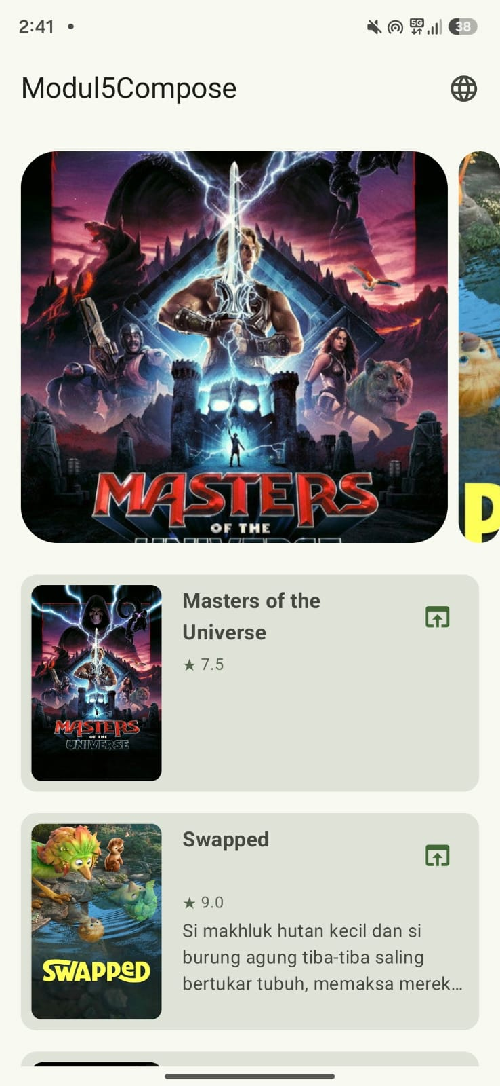Gambar 1. Output Screenshot Modul 5 (Indonesia)
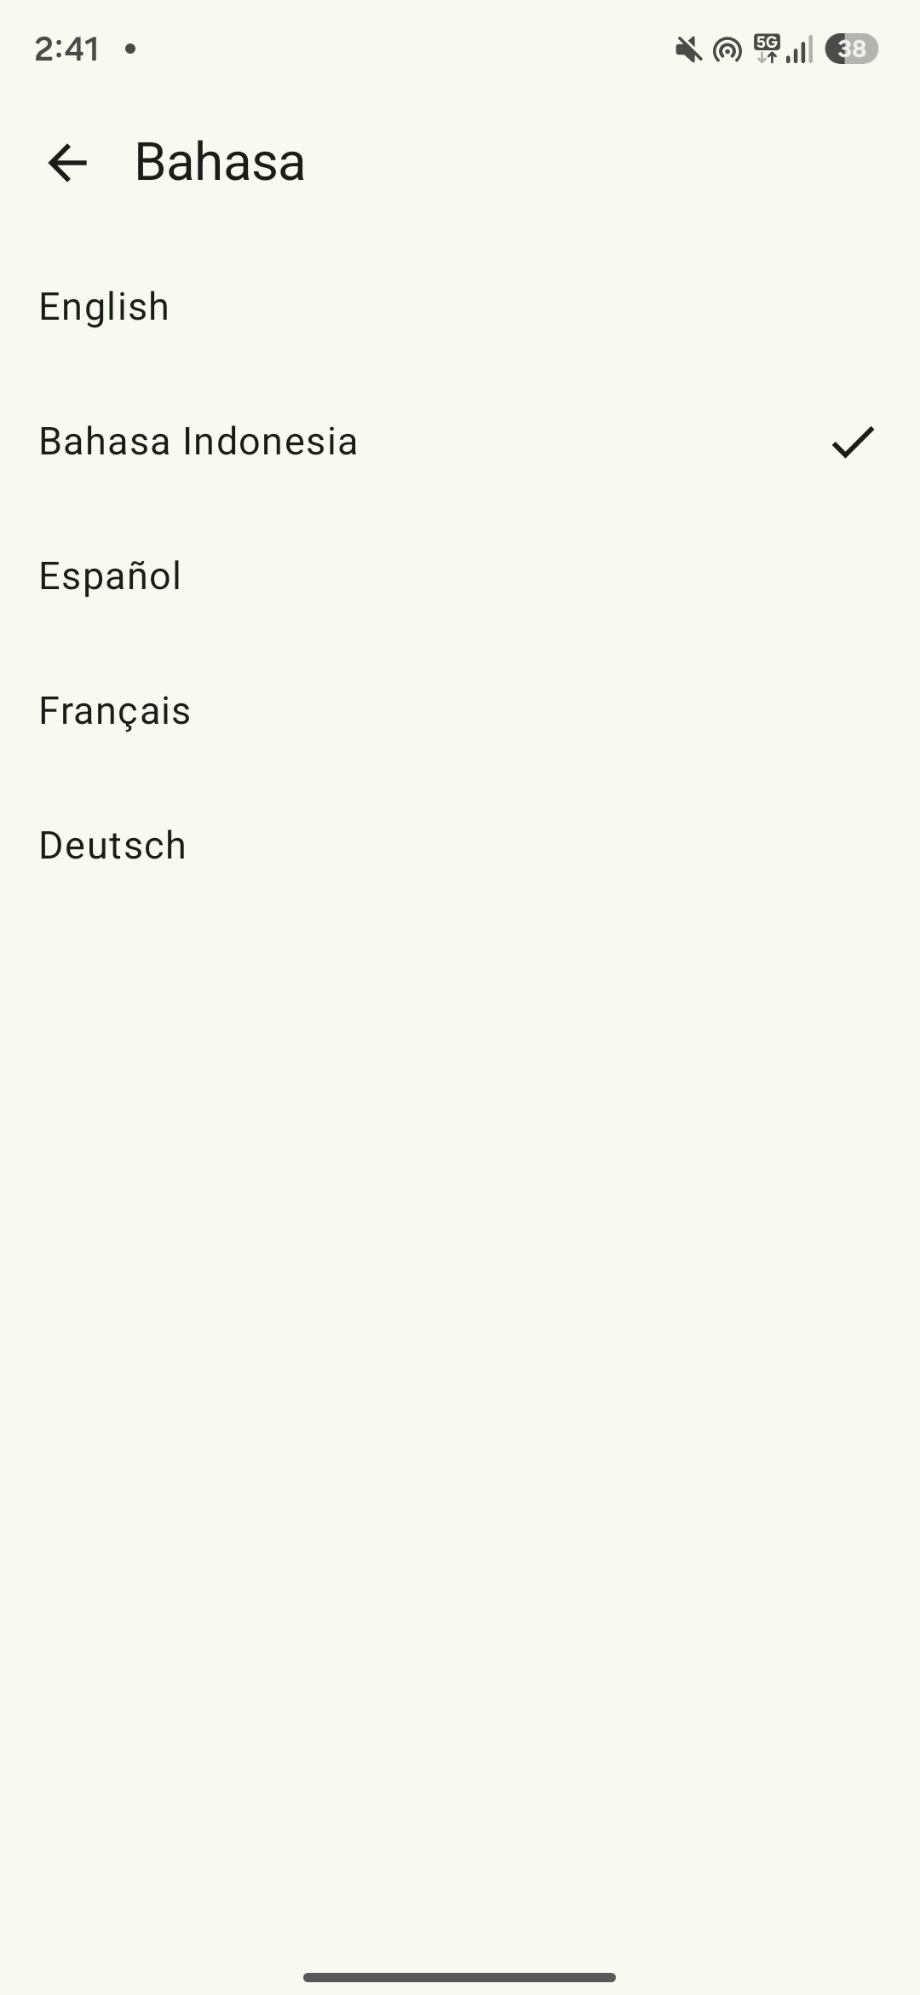Gambar 2. Output Screenshot Modul 5 (Settings)
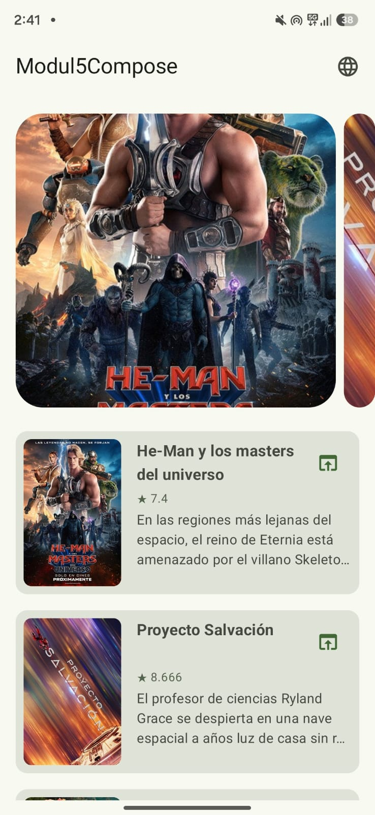Gambar 3. Output Screenshot Modul 5 (Spanyol)
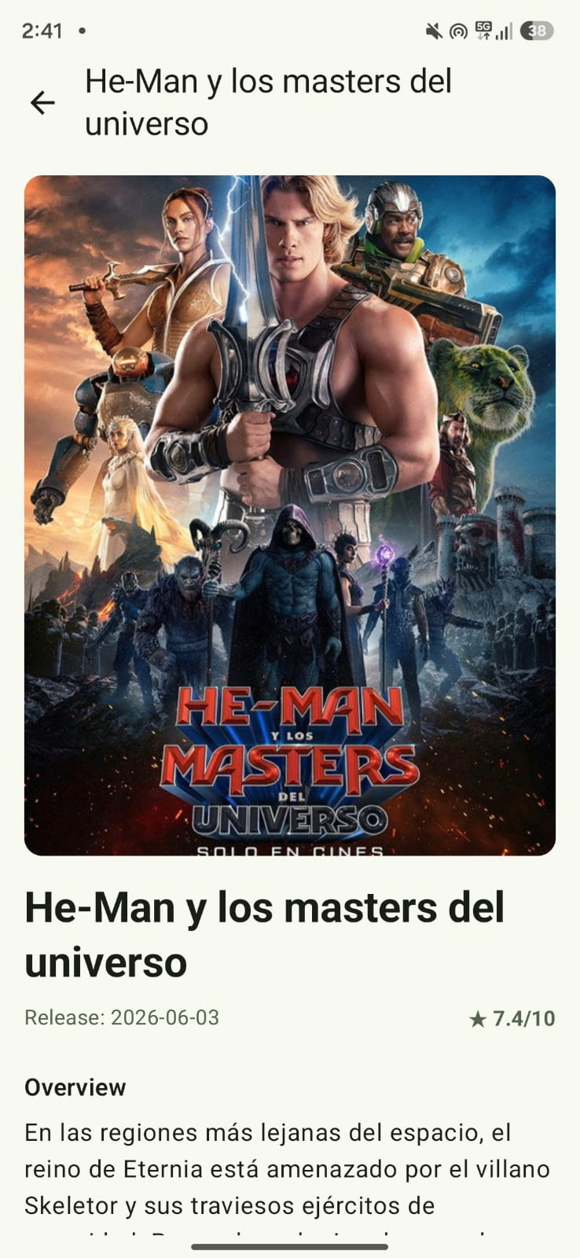Gambar 4. Output Screenshot Modul 5 (Detail Page)
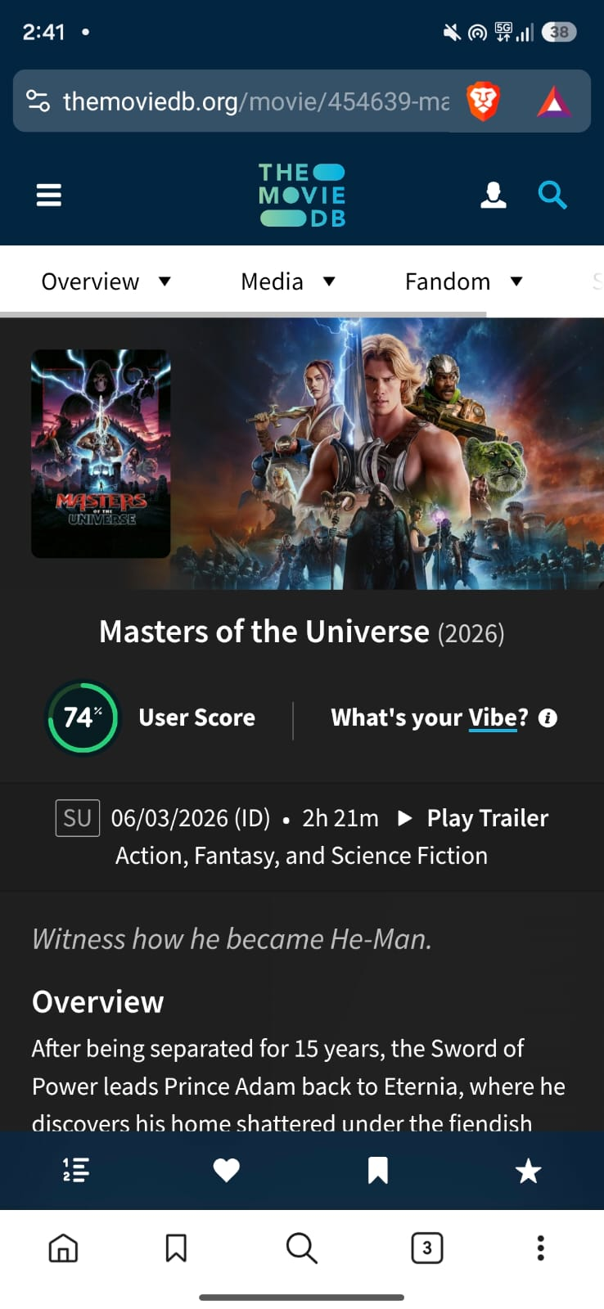Gambar 5. Output Screenshot Modul 5 (Implicit Intent)

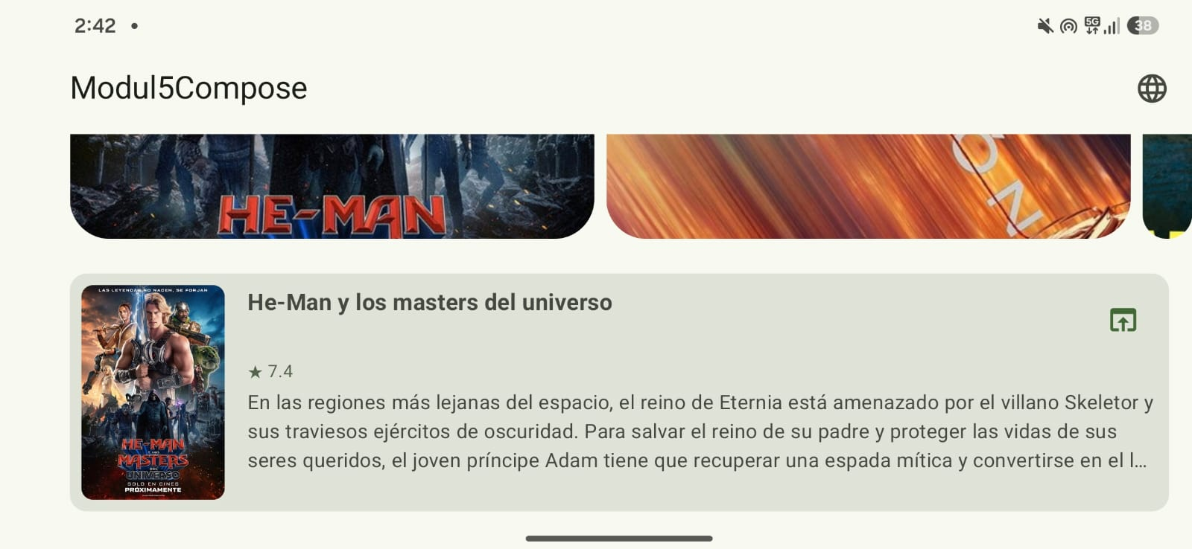Gambar 6. Output Screenshot Modul 5 (Landscape Orientation)

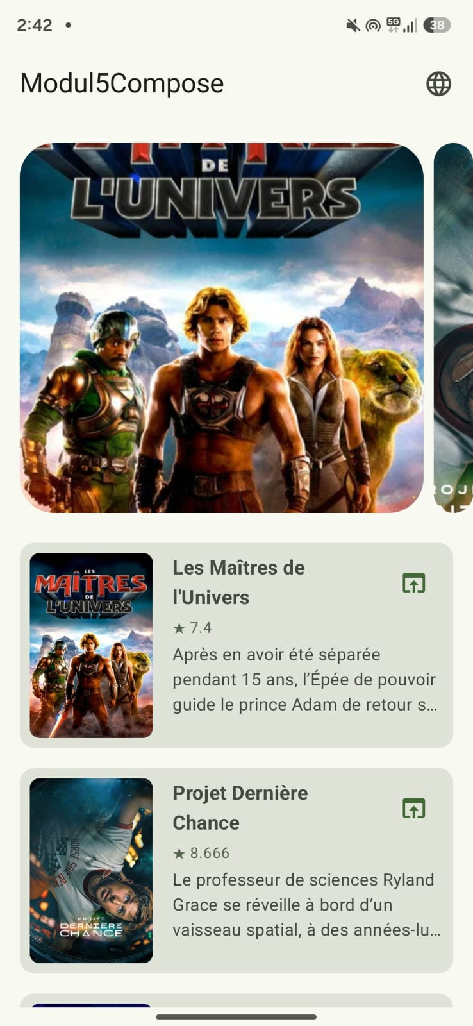Gambar 7. Output Screenshot Modul 5 (Prancis)

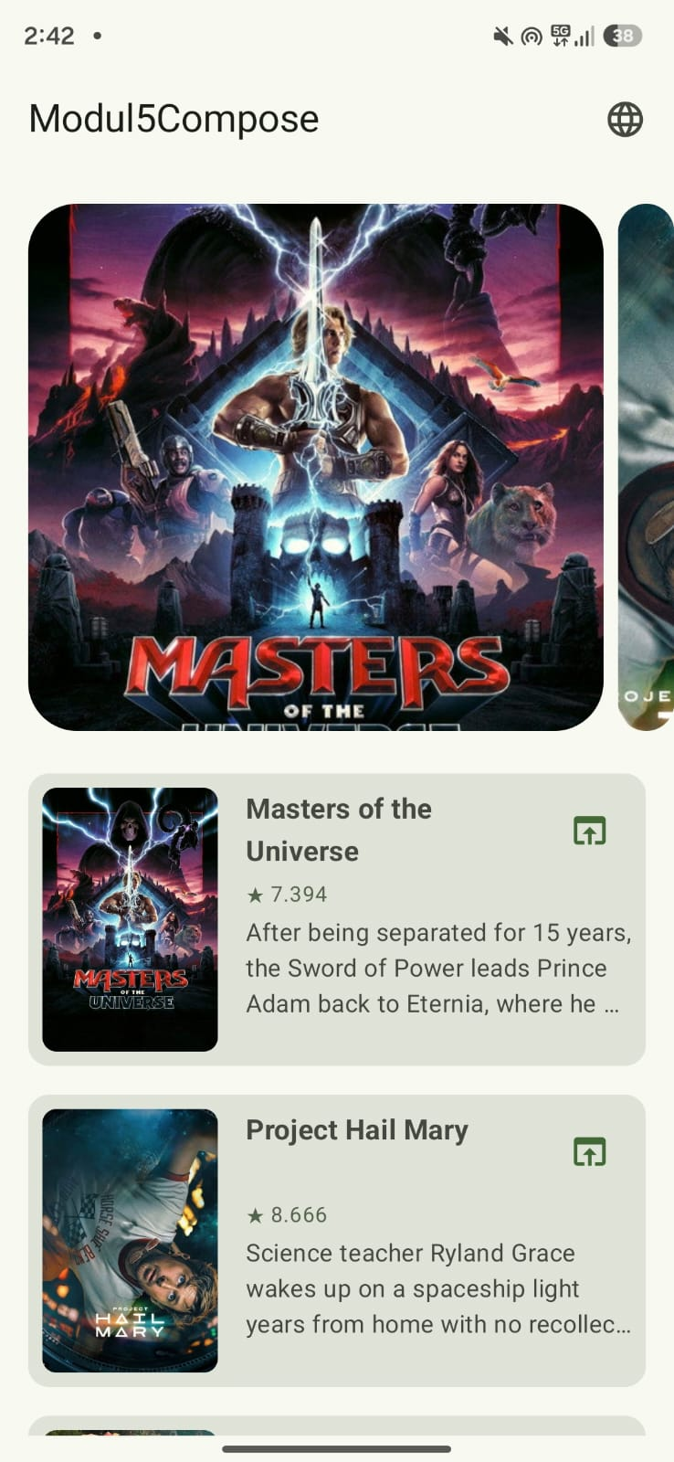Gambar 8. Output Screenshot Modul 5 (Inggris)
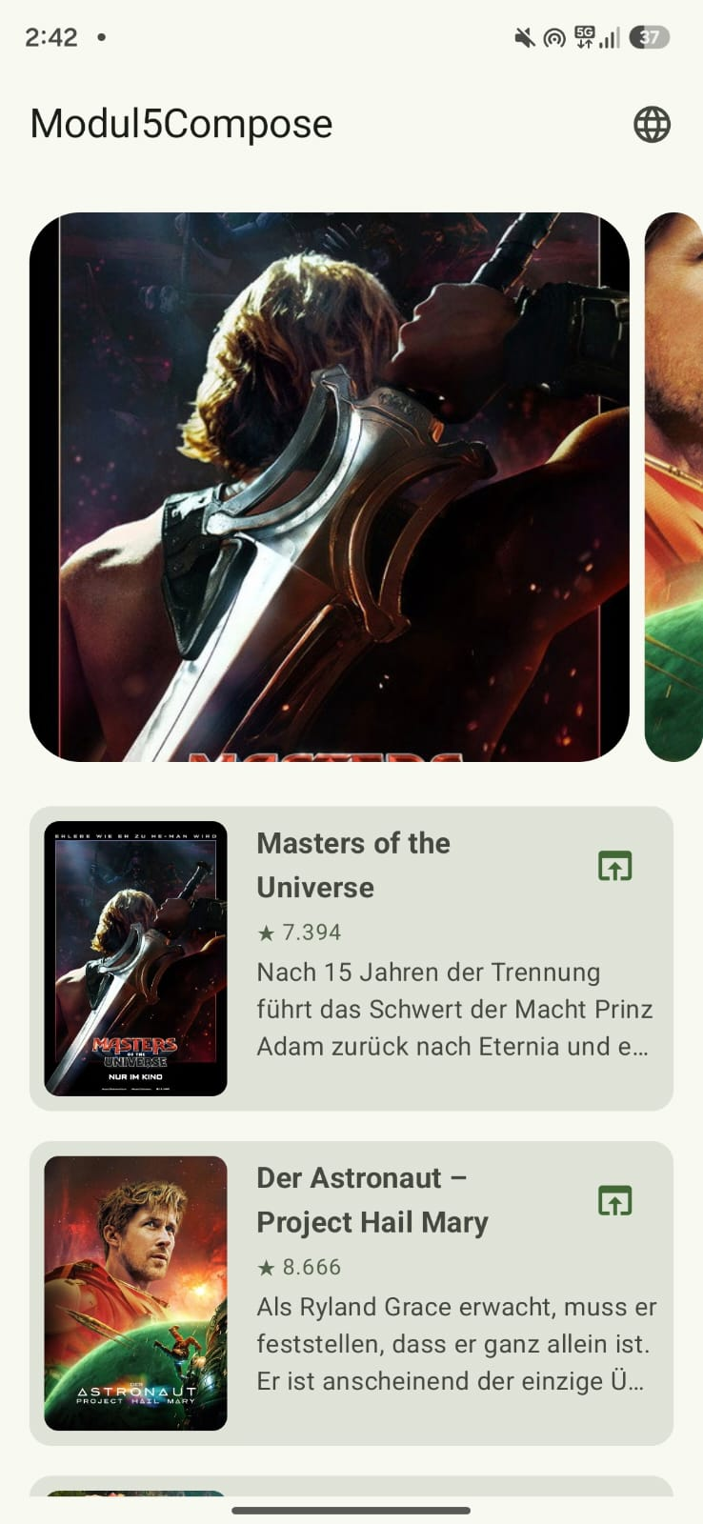Gambar 9. Output Screenshot Modul 5 (Jerman)

Pembahasan
Networking Library
Projek ini menggunakan Ktor sebagai networking library-nya. Ktor dipilih karena Kotlin-first, dan sangat fleksibel dalam konfigurasinya karena menggunakan DSL.

Client dibuat melalui implementasi HttpClientFactory yaitu TmdbClientFactory, sebenarnya bisa saja tanpa interface tapi saya ngebet mau mengaplikasikan prinsip Depedency Inversion dari SOLID. TmdbClientFactory menggunakan Engine CIO (Coroutines-based I/O) karena diberikan di contoh dokumentasinya. Base URL dan header Authorization disetting pada defaultRequest, jadi tiap kali Client melakukan request akan menggunakan base URL dan header Authorization yang sama.

Di MovieRepository, setiap fungsi memberikan data Flow<Resource<List<MovieEntity>>> atau Flow<Resource<MovieEntity>>, tidak langsung MovieEntity. Flow adalah Implementasi dari Oberserver Pattern untuk stream data secara Asynchronous, dan Resource adalah Model untuk komunikasi antara payload dan status operasi. Jadi, dengan menggunakan Flow<Resource<..>> UI bisa langsung berubah ketika terjadi perubahan di dalam MovieEntity tanpa perlu reload.

KotlinX Serialization
Untuk urusan parsing JSON, projek ini menggunakan KotlinX Serialization yang diintegrasikan langsung dengan Ktor melalui plugin ContentNegotiation.

Model response dianotasi dengan @Serializable. Di dalam model, saya banyak menggunakan anotasi @SerialName. Tujuannya untuk memetakan nama field JSON bawaan TMDB API yang menggunakan snake_case ke naming convention Kotlin yang menggunakan camelCase. Sebenarnya bisa saja dikonfigurasi secara global untuk otomatis convert penamaannya, tapi saya lebih suka menuliskannya secara eksplisit seperti ini biar tidak ada magic yang tersembunyi dan mapping-nya jelas ketika dibaca.

Pada konfigurasi Json builder-nya, saya sengaja mengaktifkan ignoreUnknownKeys = true. Ini penting banget untuk robustness. Efeknya, kalau sewaktu-waktu TMDB mengubah API mereka dan tiba-tiba mengirimkan field tambahan yang belum kita definisikan di model, aplikasi kita tidak akan langsung crash gegara gagal deserialization.
Selain itu, saya juga mendefinisikan default value berupa null pada banyak field (misal val title: String? = null). Pendekatan ini menjaga sistem tetap aman kalau ada data tertentu yang tidak dikirimkan dalam respons API. Intinya, kode ini dirancang agar long-lasting dan tidak gampang meledak dan hancur di production hanya karena masalah dari backend.

Anotasi @Serializable ini tidak cuma saya manfaatkan untuk urusan networking. Saya juga menggunakannya di RoutingNames.kt dan LanguageModel.kt. Tujuannya untuk mengimplementasikan type-safe navigation menggunakan Navigation Compose. Jadi, ketimbang pusing dan rentan typo karena melempar argumen navigasi pakai tipe String biasa, serialisasi data yang ringan ini membuat proses passing data antar view jadi jauh lebih clean dan aman dari error saat compile time.

Image Loading Library
Untuk urusan memuat gambar poster film dari TMDB di HomeScreen.kt dan DetailScreen.kt, saya memutuskan untuk menggunakan Coil (Coroutine Image Loader). Sebenarnya bisa saja pakai library legendaris seperti Glide atau Picasso, tapi karena saya fokus membangun arsitektur yang long-lasting dan sejalan dengan ekosistem modern, Coil adalah pilihan yang jauh lebih masuk akal. Coil ini dirancang Kotlin-first dan berjalan murni di atas Coroutines, jadi benar-benar terasa native dan solid ketika dikawinkan dengan arsitektur Jetpack Compose.

Di sini saya menggunakan composable AsyncImage bawaan dari coil-compose. Eksekusinya memuat gambar secara asinkron murni tanpa memblokir UI thread sama sekali.

Dari sisi robustness, menggunakan Coil menyelamatkan saya dari banyak kerumitan sistem. Library ini secara otomatis menangani layered cache dan menampilkan placeholder saat gambar sedang dimuat. Namun, dampak terbesarnya bagi performa aplikasi secara keseluruhan adalah kemampuannya membatalkan request secara otomatis ketika composable keluar dari komposisi layar misalnya saat user melakukan scroll dengan cepat. Ini krusial banget untuk mencegah memory leak dan memastikan aplikasi tidak rakus resource.

Untuk URL path-nya, saya merangkainya langsung dari TMDB dengan mematok ukuran w500. Ini adalah keputusan pragmatis; ukurannya sudah sangat pas dan cukup tajam untuk merender tampilan list maupun detail. Jadi, kita tidak perlu membuang-buang kuota user atau mengorbankan performa rendering dengan mengunduh file gambar yang kelewat besar.
TMDB API
Projek ini mengonsumsi The Movie Database (TMDB) API dengan dua endpoint utama.

Endpoint yang digunakan:
client.get("movie/popular?language=$currentLanguage")
client.get("movie/$movieId?language=$currentLanguage")

Parameter language dikirim secara dinamis sesuai preferensi user yang tersimpan di SettingsRepository. Autentikasi menggunakan Bearer Token (Read Access Token) yang disisipkan di header setiap request lewat defaultRequest di TmdbHttpClientFactory. Token disimpan aman di secrets.properties, tidak di-commit ke repositori, ada file secrets.properties.example sebagai panduan.

Response dari endpoint list disimpan dalam TmdbListResponse yang memiliki atribut result: List<MovieResponse>, kemudian di-mapping ke MovieEntity melalui extension function toEntity() di MovieHelper.kt sebelum disimpan ke Room.

Caching Strategy
Projek ini menggunakan strategi Cache-First with Network Fallback yang diimplementasikan melalui pola NetworkBoundResource.

Alur kerjanya, pertama membaca cache dari Room, lalu memutuskan apakah perlu fetch ke network berdasarkan shouldFetch. Untuk daftar film, fetch dilakukan hanya jika cache kosong (cachedList.isNullOrEmpty()). Untuk detail film, fetch dilakukan jika data belum ada di cache (cachedEntity == null). Jika fetch berhasil, data disimpan ke Room dan langsung di-emit. Jika gagal, cache lama tetap ditampilkan bersama pesan error.

Alasan saya memilih strategi ini karena data film dari TMDB tidak sering berubah, daftar film populer cukup stabil dalam jangka pendek. Dengan strategi ini, aplikasi tetap dapat digunakan saat offline dengan menggunakan data cache, dan UI tidak perlu menunggu network sebelum menampilkan konten. Selain itu, MovieEntity menyimpan field cachedAt: Long yang memungkinkan development lebih lanjut untuk invalidasi cache berdasarkan time-based expiry.

UI
Sistem UI projek ini saya bangun full menggunakan Jetpack Compose. Saya sengaja menerapkan arsitektur MVVM dengan batasan yang sangat tegas antara Screen, ViewModel, dan State. Kenapa? Supaya kodenya long-lasting, scalable, dan gampang di-test. Komponen layarnya saya pecah jadi tiga: State, ViewModel, dan Screen.

Untuk urusan navigasinya, sebenarnya bisa saja pakai string route biasa yang lebih cepat dibikin, tapi saya ngebet mau mengaplikasikan type-safe routes bawaan Navigation Compose terbaru. Dengan mendefinisikan route sebagai sealed class beranotasi @Serializable di RoutingNames.kt, saya bisa memastikan aplikasi aman dari crash gak seru hanya gara-gara typo nama screen atau argumen yang salah tipe data.

HomeScreen
Di HomeScreen, state dari ViewModel saya konsumsi menggunakan collectAsState(), jadi UI akan langsung recompose secara otomatis tiap kali datanya berubah.

Tantangan di Compose biasanya ada di navigation event. Kalau tidak hati-hati, layar bisa pindah berkali-kali saat terjadi recomposition. Untuk mengakalinya, event navigasi ini saya modelkan sebagai field nullable di dalam HomeState. Ketika nilainya tidak null, navigasi langsung diproses di dalam LaunchedEffect, lalu di-reset kembali ke null.

Secara tampilan, saya membaginya jadi dua: MovieCarousel di atas yang menggunakan HorizontalMultiBrowseCarousel sebenarnya ini API Material3 yang masih experimental, tapi saya pakai karena cocok untuk menampilkan 5 film, dan LazyColumn di bawahnya untuk daftar film biasa.

Di level arsitektur yang lebih luas, HomeViewModel terus-terusan mengobservasi perubahan languageTag dari repository. Efeknya sangat smooth, setiap kali user mengganti bahasa, job pengambilan data yang lama akan dibatalkan, dan data baru dengan bahasa yang sesuai akan langsung di-reload secara asinkron tanpa mengganggu flow UI.

DetailScreen
Masuk ke DetailScreen, layar ini bertugas menampilkan informasi lengkap film berdasarkan movieId yang dipassing secara type-safe tadi.

Begitu DetailViewModel menerima movieId, dia akan langsung memanggil repository.getMovie(movieId). Nah, di repository inilah keajaibannya terjadi. Saya menerapkan pola NetworkBoundResource. Pola ini membuat aplikasi jadi kebal terhadap koneksi internet yang jelek. Sistem akan langsung menampilkan data cache dari database lokal sambil melakukan fetching API di background.

Kalau API tiba-tiba error atau internet mati, aplikasi tidak akan crash atau menampilkan blank screen. Film tetap ditampilkan dari cache, dan user hanya diberikan pesan error kecil di overlay. Ini benar-benar menjaga robustness aplikasi di production.

LanguageScreen
LanguageScreen bertugas mengurus preferensi bahasa yang persistent. UI-nya cukup simpel dengan LazyColumn berisi opsi bahasa.

Ketika user memilih bahasa, LanguageViewModel mengeksekusi dua tindakan krusial. Pertama, dia memanggil AppCompatDelegate.setApplicationLocales() untuk mengubah locale aplikasi di level sistem, sehingga semua string resources bawaan langsung diterjemahkan. Kedua, memanggil repository.saveLanguageTag(tag) untuk menyimpannya ke SharedPreferences supaya preferensinya tidak hilang saat aplikasi mati.

Karena SettingsRepository mengekspos bahasa ini dalam bentuk StateFlow<String>, sistem menjadi murni reaktif. Semua Screen dan ViewModel yang bergantung pada bahasa seperti HomeViewModel, akan langsung bereaksi terhadap perubahan tanpa perlu kita perintahkan. Hasil akhirnya, UI aplikasi akan berubah bahasa on-the-fly secara elegan tanpa perlu merestart aplikasi.

LINK GITHUB
https://github.com/Gunturadhtya/Praktikum-Pemrograman-Mobile

